EXPT NO: 4 | TRANSFER LEARNING USING PRE-TRAINED VISION MODELS FOR IMAGE RECOGNITION
DATE: 30-08-26

PRE-LAB QUESTIONS

- What is transfer learning in deep learning?
Transfer learning is a deep learning technique where a model trained on a large dataset is reused for a new related task. The pre-trained model already contains useful features learned from the original dataset. Instead of training the entire model from the beginning, these learned features are transferred to the new problem. The final classification layer is usually replaced according to the classes in the new dataset. This approach reduces training time and can provide good performance even with limited data.

- What are the advantages of using pre-trained models over training from scratch?
Pre-trained models reduce the amount of time and computational resources required for training. They already contain useful visual features learned from large image datasets. They generally require fewer training epochs to achieve good accuracy on a new task. They can perform well even when the new dataset contains a relatively small number of images. Therefore, pre-trained models make deep learning development faster, easier, and more efficient.

- What is the role of fine-tuning in transfer learning?
Fine-tuning is the process of training some of the pre-trained model's layers on the new dataset. Initially, the feature extraction layers may be frozen so that their learned features are preserved. Afterwards, selected deeper layers can be unfrozen and trained with a small learning rate. This allows the model to adapt its learned features to the specific characteristics of the new dataset. Fine-tuning can improve the model's accuracy compared with using the pre-trained model without modification.

- Name any three popular pre-trained computer vision models.
Three popular pre-trained computer vision models are ResNet-50, AlexNet, and VGGNet. ResNet-50 uses residual connections to make training deep neural networks easier. AlexNet is an important convolutional neural network that achieved major success in image classification. VGGNet is known for its simple architecture using multiple convolutional layers. These models can be reused for new image recognition tasks through transfer learning.

- What is the purpose of Hugging Face and how is it useful in deep learning?
Hugging Face provides a platform and libraries containing many pre-trained machine learning models. It allows developers and students to easily access and experiment with models for different tasks. For computer vision, Hugging Face provides pre-trained vision models that can be used for image classification. It reduces the complexity of downloading, loading, and experimenting with advanced models. This makes deep learning experimentation and model development faster and more convenient.

AIM
To implement transfer learning using pre-trained vision models for image recognition and evaluate their performance on real-world image datasets.

SOFTWARE REQUIREMENTS
- Python
- TensorFlow/Keras or PyTorch
- Google Colab
- Hugging Face Transformers
- Kaggle Dataset
- Matplotlib
- GitHub

OBJECTIVES
Students will be able to:
- Understand the concept of transfer learning.
- Apply pre-trained vision models for image recognition.
- Fine-tune models such as ResNet or AlexNet.
- Utilize Kaggle datasets and Hugging Face vision models.
- Compare transfer learning performance with custom CNN models.

Task A: DATASET PREPARATION
Perform the following tasks:
- Download an image dataset from Kaggle.
- Load and preprocess the images.
- Split the dataset into training, validation, and testing sets.

Task B: IMPLEMENTING TRANSFER LEARNING
Load a pre-trained model such as:
- ResNet-50
- AlexNet
Replace the final classification layer according to the dataset classes.
Freeze the feature extraction layers.
Compile the model.

Task C: MODEL TRAINING AND PERFORMANCE EVALUATION
Train the transfer learning model.
Record:
- Training accuracy
- Validation accuracy
- Training loss
- Validation loss
- Test accuracy
Visualize:
- Accuracy vs Epoch
- Loss vs Epoch

Task D: USING HUGGING FACE PRE-TRAINED MODELS
Perform the following tasks:
- Load a pre-trained vision model from Hugging Face.
- Perform image classification on sample images.
- Compare predictions with the transfer learning model.
- Document observations and upload the notebook to GitHub.

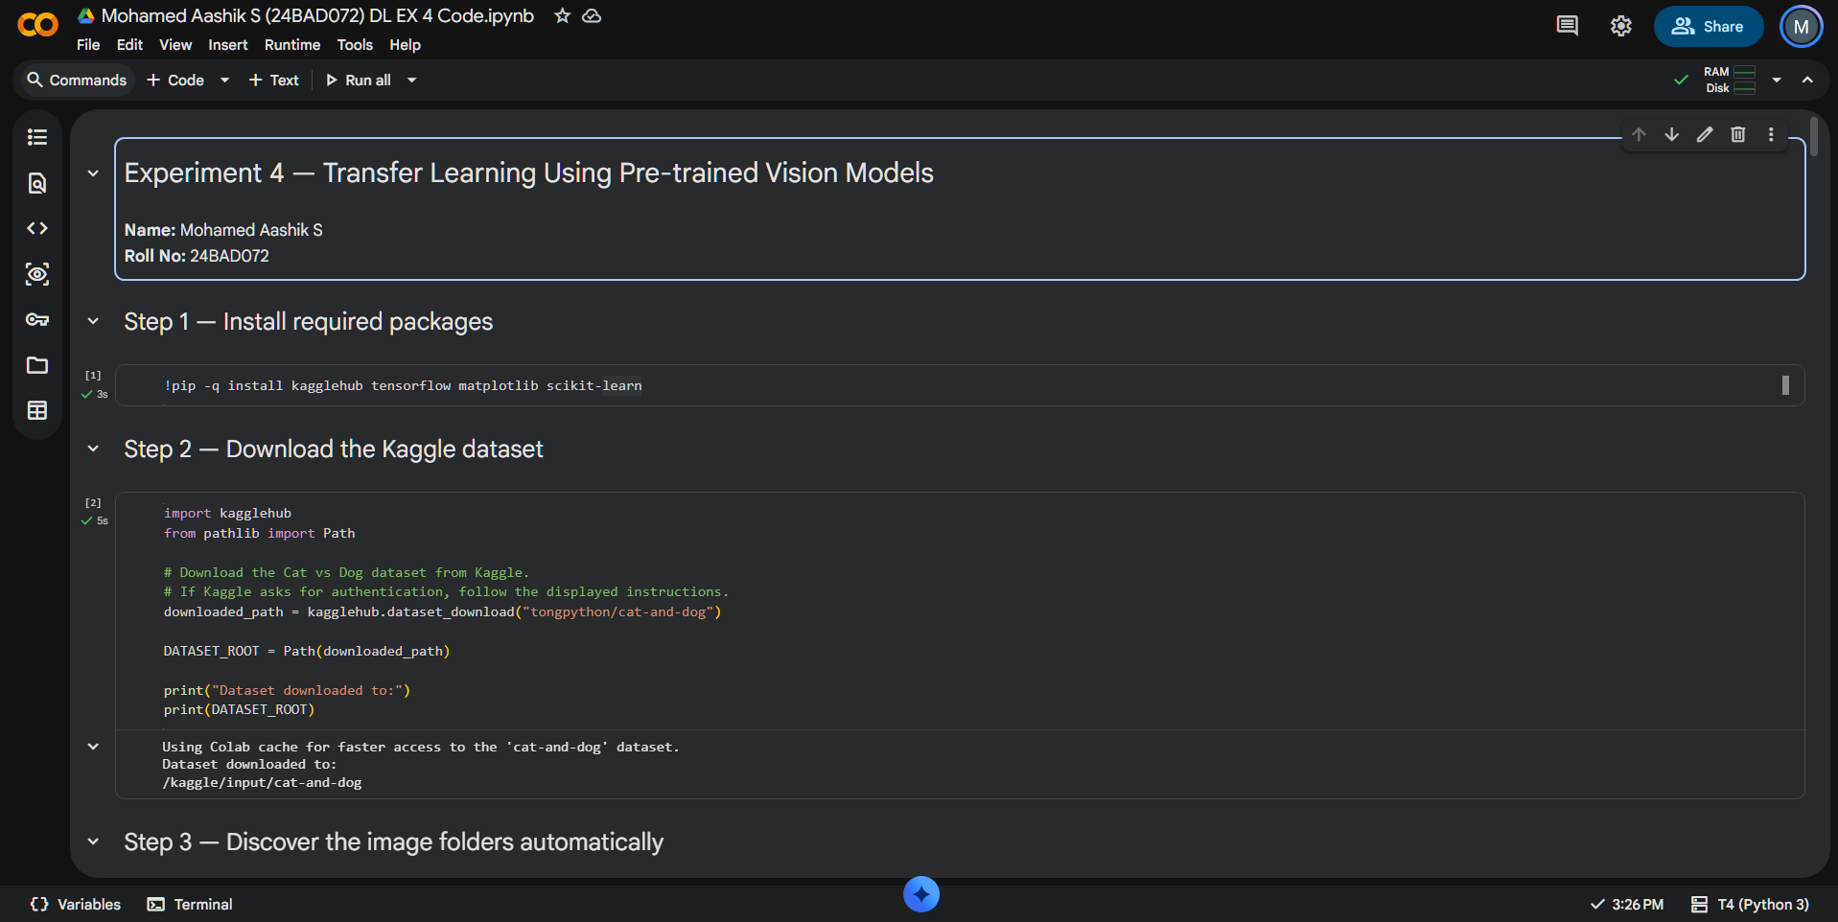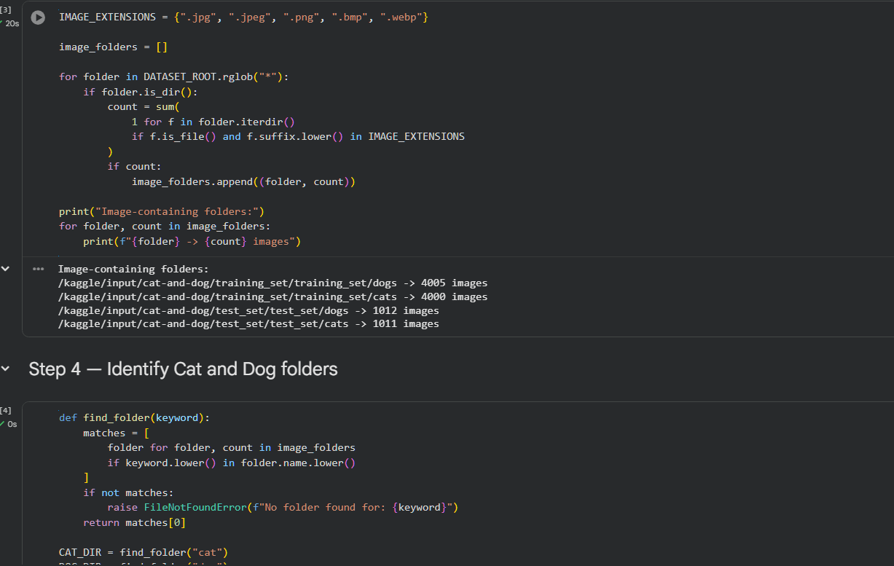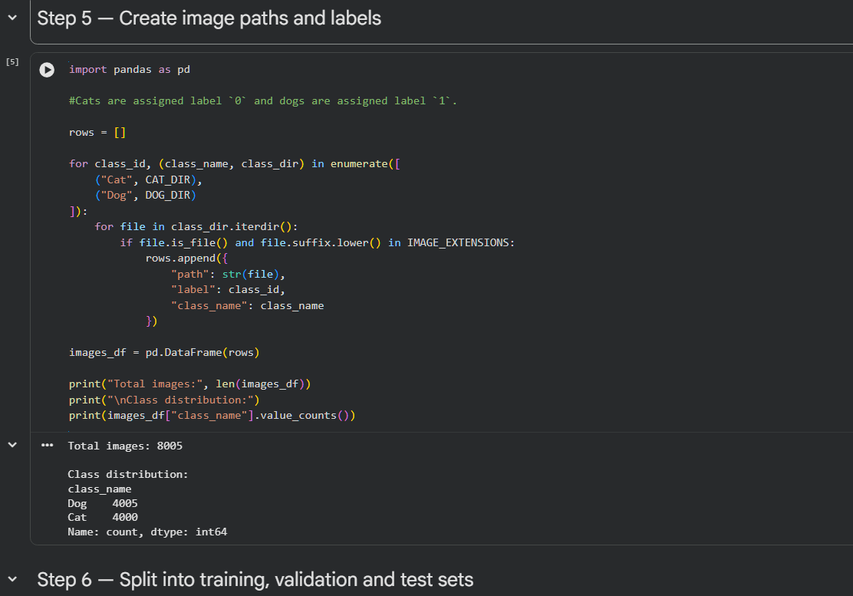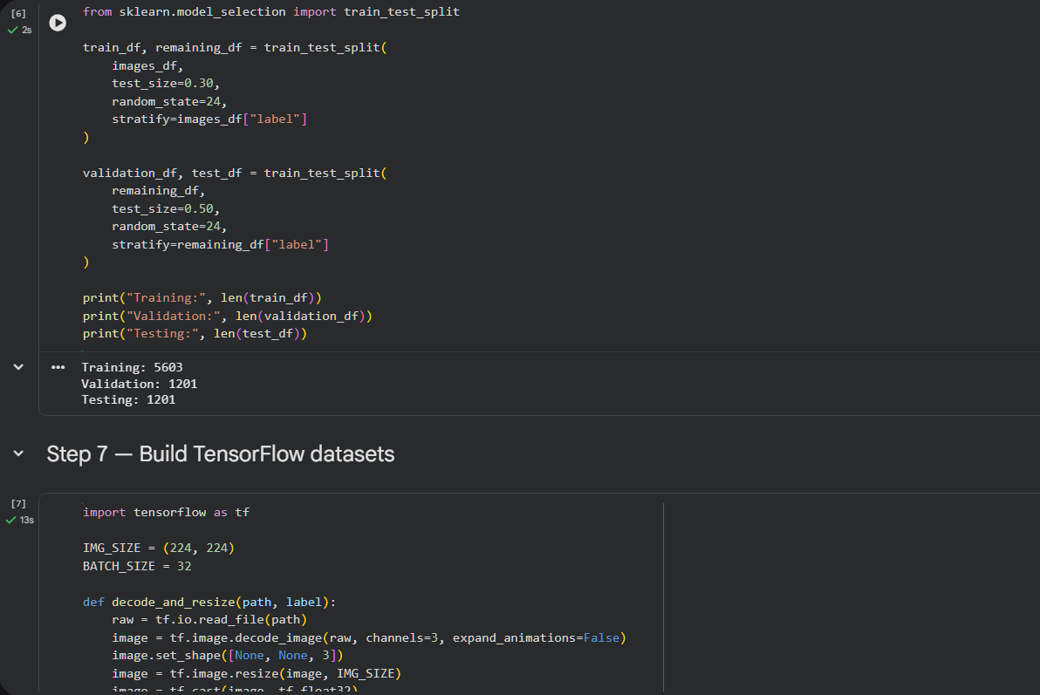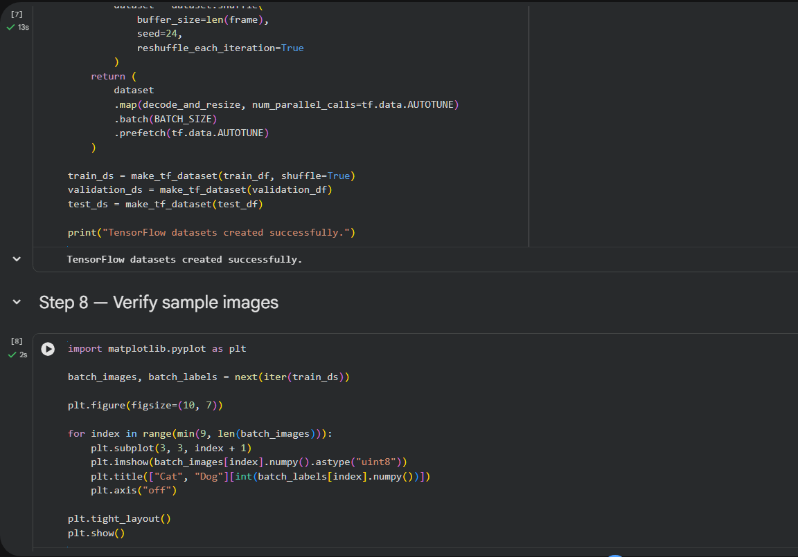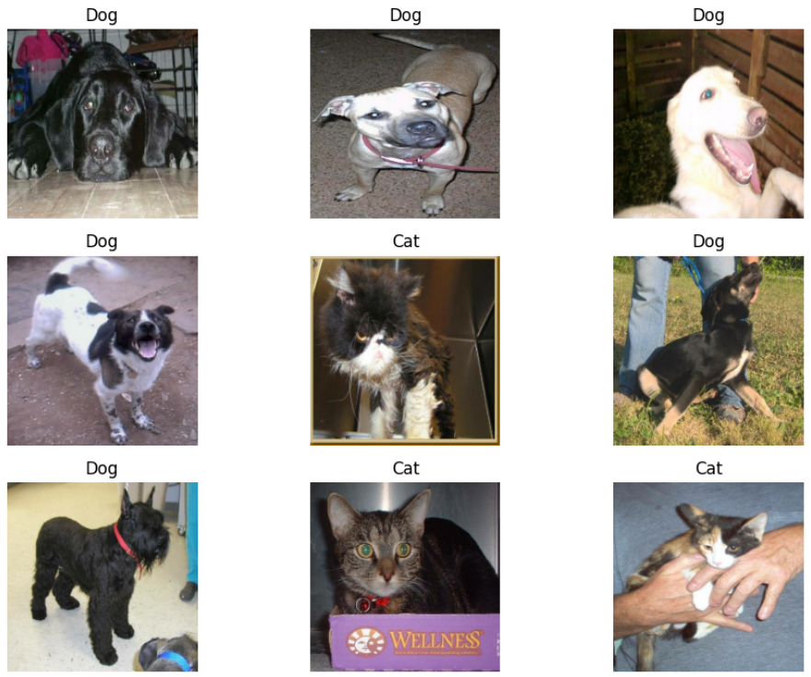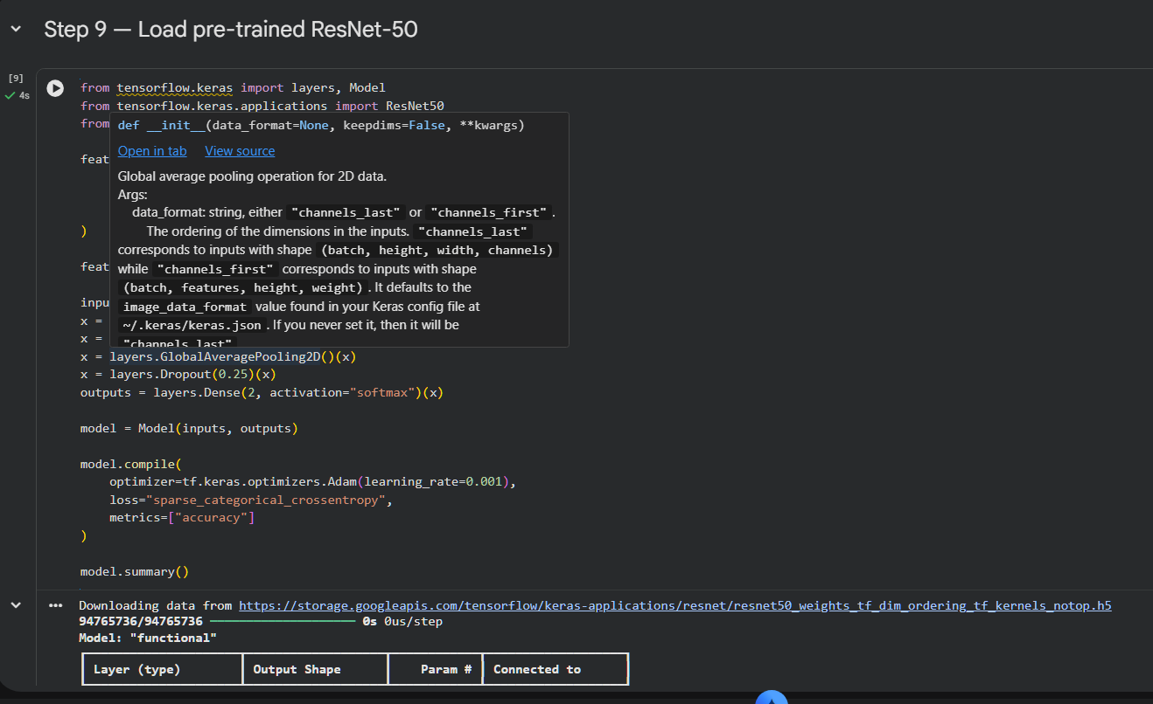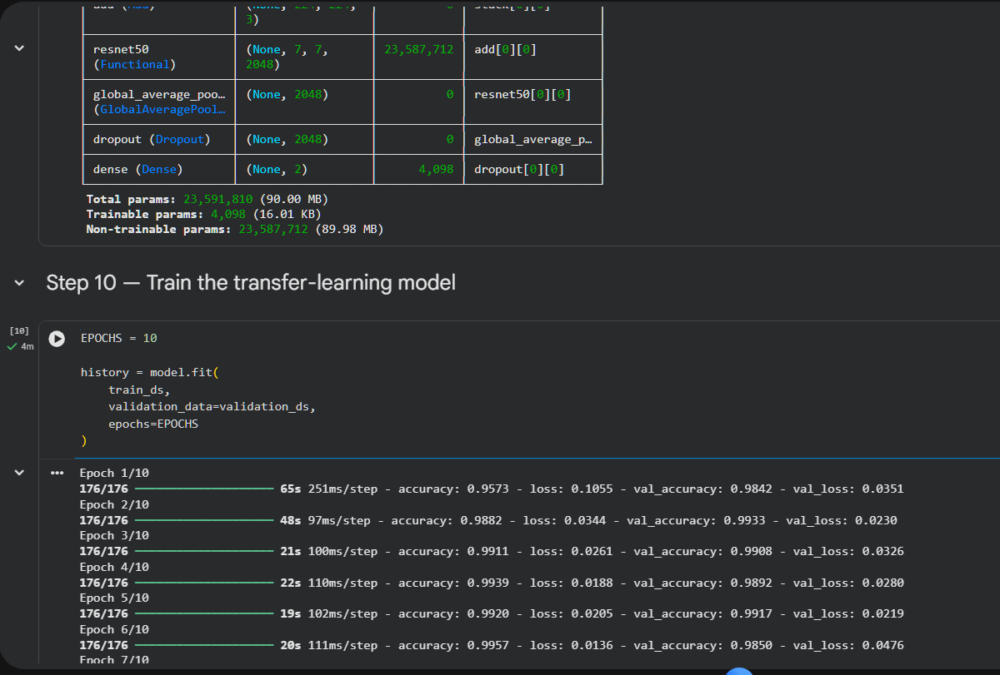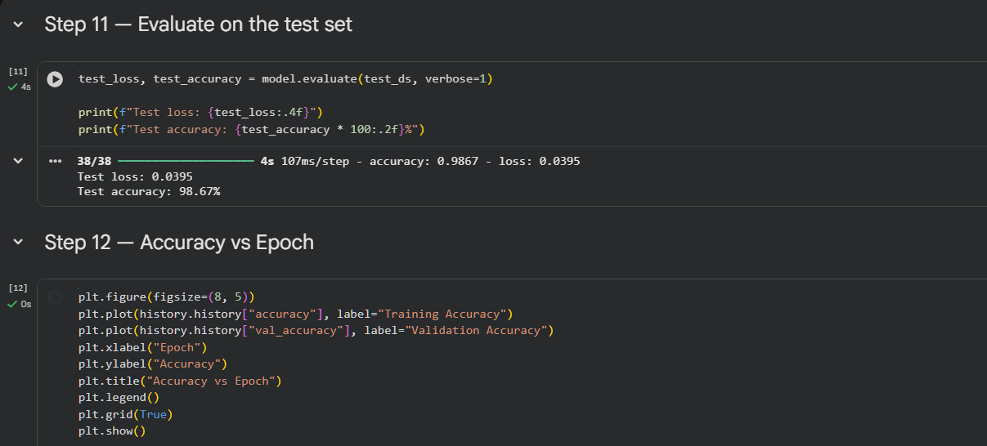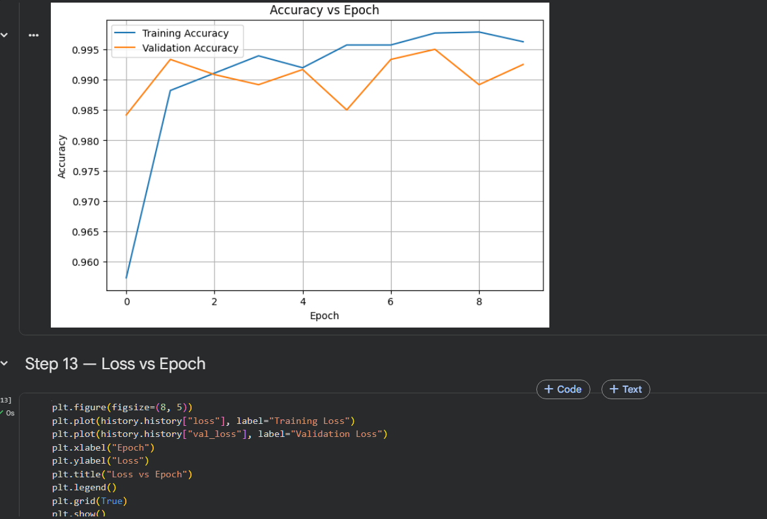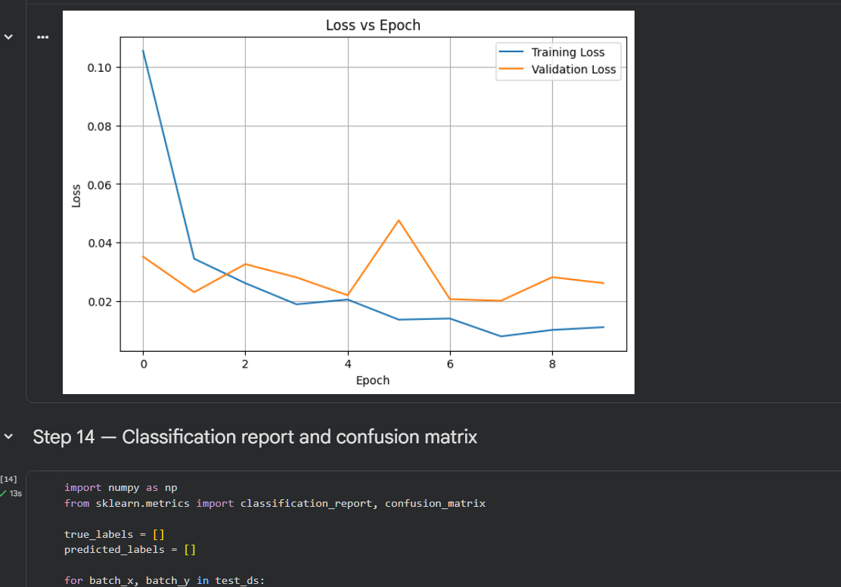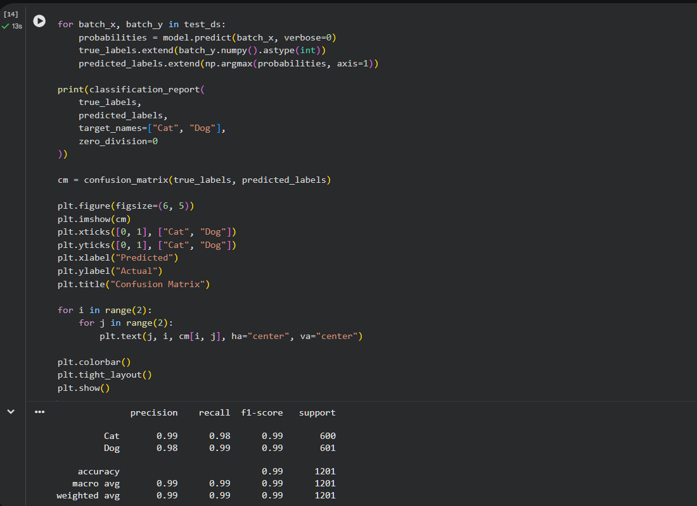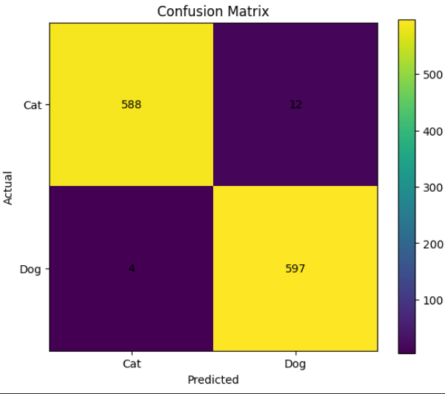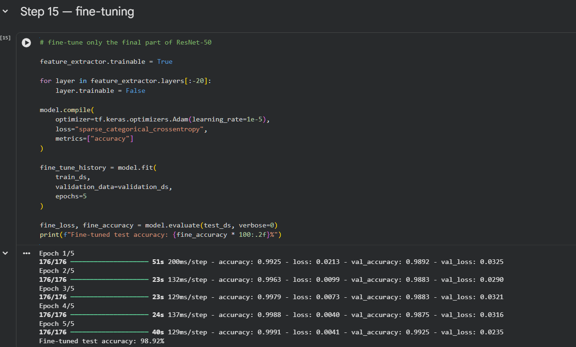
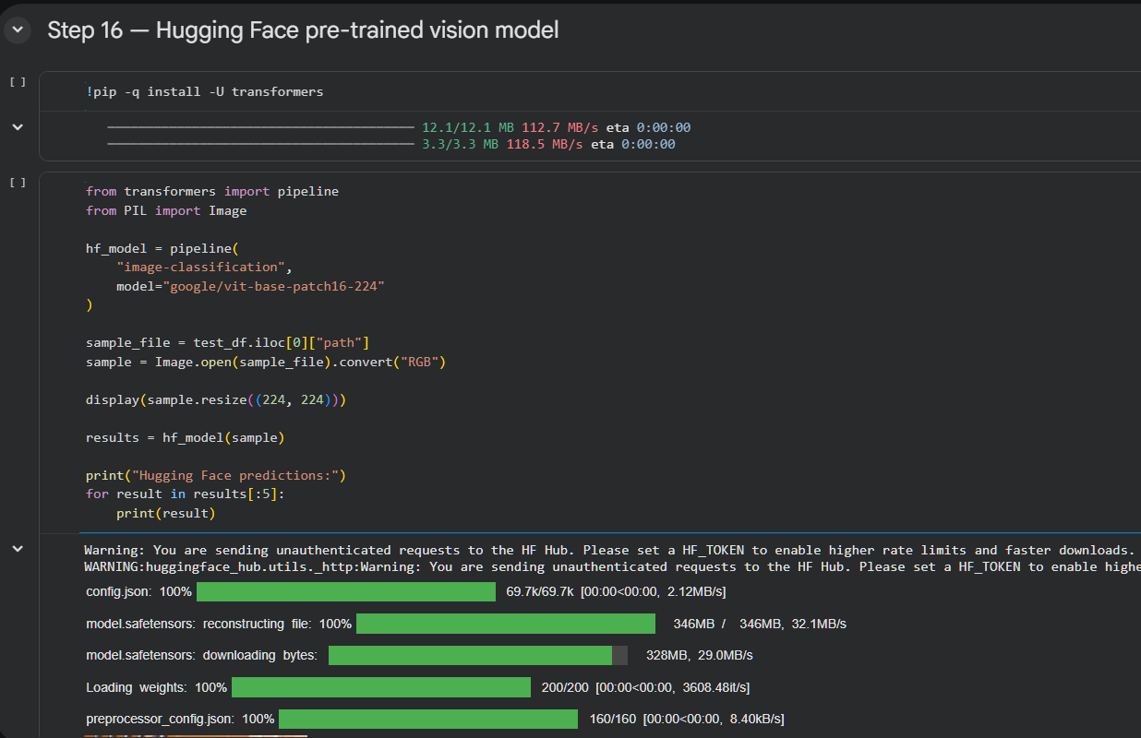 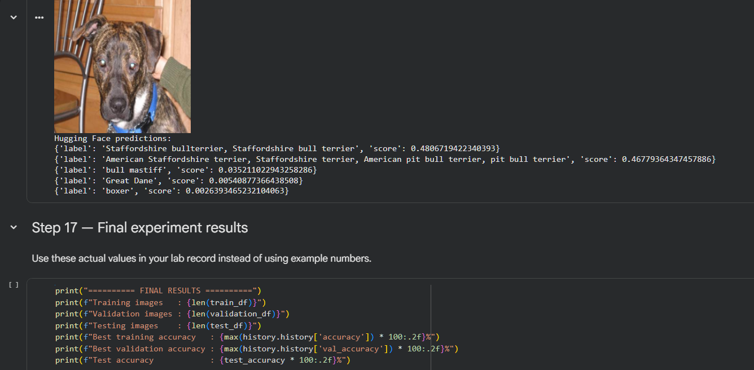 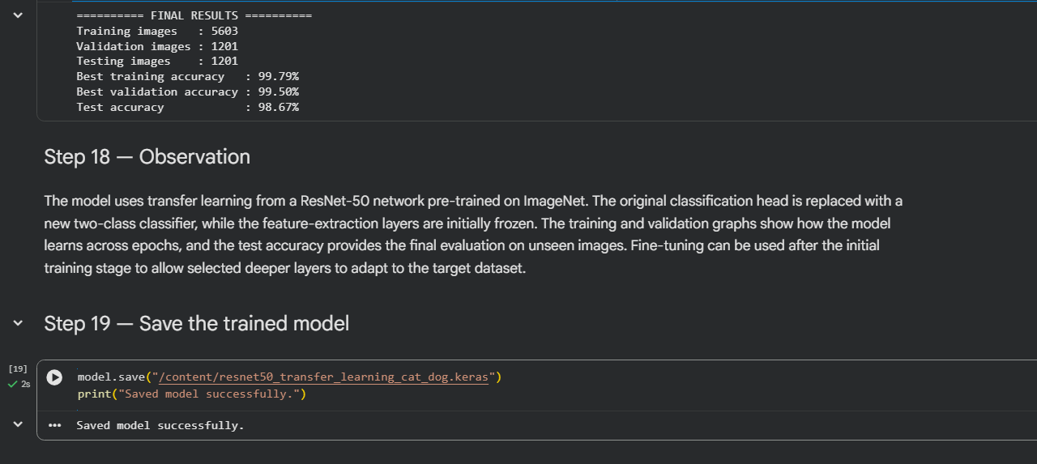––––––––––––––

POST-LAB QUESTIONS

  - What are the advantages of transfer learning compared to training a CNN from scratch?
Transfer learning uses knowledge already learned by a model from a large dataset. It reduces training time and requires fewer computational resources than training a CNN from scratch. It can achieve good accuracy even when the available dataset is relatively small. The pre-trained features provide a strong starting point for learning the new classification task. Overall, transfer learning makes image recognition development faster, more efficient, and often more accurate.

  - Why are pre-trained models able to achieve higher accuracy with fewer training epochs?
Pre-trained models have already learned useful features such as edges, shapes, textures, and patterns from large datasets. Therefore, they do not need to learn these basic visual features again from the beginning. Only the features specific to the new dataset need to be adapted during training. This allows the model to reach useful accuracy in fewer training epochs. As a result, pre-trained models can provide faster convergence and efficient learning.

  - Compare the performance of the transfer learning model with the CNN implemented in the previous experiment.
The transfer learning model generally provides better performance than a CNN trained from scratch when the dataset is limited. It can achieve higher validation and test accuracy because it starts with useful features learned from a large dataset. It also usually requires fewer epochs and less training time to reach good performance. The CNN from the previous experiment has to learn its features entirely from the available training data. Therefore, transfer learning is generally more efficient, although the exact accuracy depends on the dataset and model used.

  - What is the purpose of freezing layers during transfer learning?
Freezing layers prevents their weights from being updated during the training process. The early layers of a pre-trained model usually contain general features that are useful for many image recognition tasks. Keeping these layers frozen preserves the knowledge learned from the original large dataset. It also reduces the number of trainable parameters and therefore decreases training time and computational requirements. The later classification layers can then be trained to recognize the specific classes in the new dataset.

  - How can Hugging Face simplify the deployment and experimentation of vision models?
Hugging Face provides easy access to many pre-trained vision models through its libraries and model repository. Users can load an existing model without implementing its complete architecture from scratch. It makes it easier to test image classification models on sample images and compare their predictions. This reduces development effort and allows students and developers to experiment with advanced models quickly. Hugging Face therefore simplifies both experimentation and the practical use of pre-trained vision models.

ASSESSMENT
Description | Max Marks | Marks Awarded
Pre Lab Exercise | 5
In Lab Exercise | 10
Post Lab Exercise | 5
Viva | 10
Total | 30
Faculty Signature

